**BACK PROCESS**

**This project integrates Angular for the frontend and Django for the backend to build a dynamic and interactive web application. Key highlights of the workflow include:**

Backend Powered by Django:

Django Models: Structured models connected to a PostgreSQL database for efficient data management.

API Endpoints: Secure REST APIs using Django REST Framework for seamless GET and POST operations.

Backend Initialization: Django server is launched first to establish database connections and enable API endpoints.

BY RUNNING DJANGO AND ANGULAR

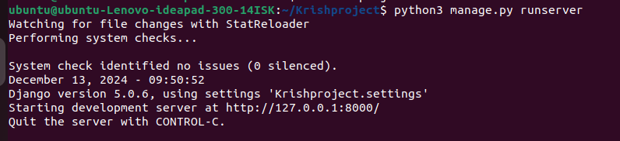

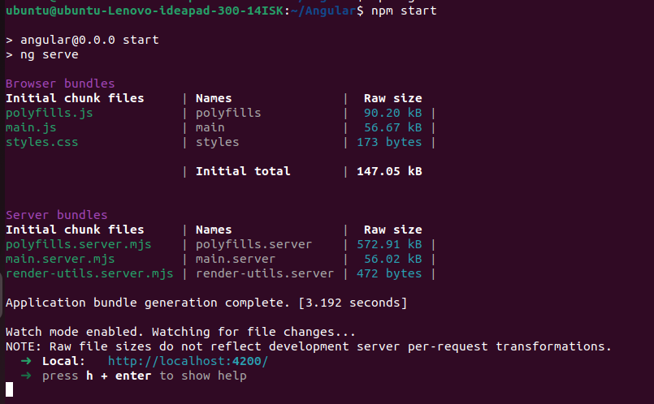

Database Management:

PostgreSQL serves as the database for structured and scalable data storage.

Tables are designed to manage application-specific data effectively.

Frontend Development with Angular:

Component Design: Angular components display and interact with data dynamically.

Responsive UI: Optimized layouts ensure smooth functionality across devices.

Service Integration: Angular services fetch and post data via Django APIs.

**To Create our project website we created the different components in Angular based on what we want.**

**Here, our components are**

* **Header Component**
* **Main – Nav Component**
* **Home Component**
* **About Component**
* **Courses Component**
* **Student-information Component**
* **Add student Component**
* **Sidebar-Left Component**
* **Sidebar-Right Component**
* **Footer Component**

**At each component we have defined differnt things what we need.**

End-to-End Integration:

Real-Time Interaction: Angular fetches backend data for display and updates PostgreSQL through form submissions.

Development Workflow: Start the Django server for backend operations and Angular development server for frontend functionalities.